CuPIDO Tower Site Directions – 16 Jul 2006
- Cacti are ubiquitous and require protection from with good boots. Take 2 gal water. Know sat phone. Check in by sat phone if working alone off Redington Rd.
- St 3 (ENE) and St 4 (E) are the most arduous. From the south each is 2 hr one way. From the north 2.5 hr each. They are 1.5 hr apart and are subject to temporary inaccessibility due to flash flooding and potentially difficult access/egress during monsoon rains.
- Site 6 requires a 120 vertical foot hike in moderately steep terrain (5 min).
- Site 10 requires a moderately steep 50 vertical foot hike from the road (2 min)
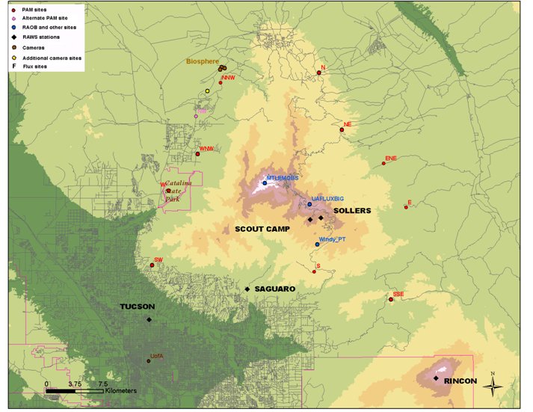
S3 - 2.25h
S2 - 2.0h
S1 - 1.5h
S4 - 2.0h
S6 - 0.65h
S5 - 0.75h
S7 – 0.5h
S8 – 0.7h
S9 – 0.8h
S10 – 0.9h
Times listed are from the ISFF Base/ResInn non-stop or site-site only (arched line segments).
Time from Base to Res Inn = 20-30 min dep traffic
RInn
Base
0.5
2.0
0.3
0.4
0.5
0.8
1.0
1.2
1.5
Go from the south/SE to sites 3, 4, 5 and 6
Go from the north for all other sites
1. N, Campo Bonito – Basic site - 32 deg 34.304', W 110 deg 42.401' El 4362’
It is fastest to go up Oracle Road from the Base (west side of Mt. Lemmon) to Site 1.
- Take Oracle Road North (also Hwy 77) ~ 35 miles and go RIGHT onto W. American Way toward the town of Oracle.
- After a few miles, 0.5 mile past the second(!) Oracle CircleK, at the city library, bear RIGHT on Mt. Lemmon Highway.
- Follow it 3 mi to where it turns to gravel at a fork (stay RIGHT on Mt. L. Hwy, the left goes onto Webb Road toward San Manuel and Sites 3, 4 and Redington Road).
- Go ~1.5 mi on dirt to Campo Bonito Road (at the top of a small rise) and go LEFT (E).
- The site is 0.5 mi on the right (if you get to Happy Thoughts Road you went too far).

2. NE, Stratton Canyon – Flux site – 32d 30.242', 110d 40.772', El 4560'
Follow the directions to Site 1 to where Mt. Lemmon Highway turns to gravel.
Go 10.9 miles (6.3 miles beyond Peppersauce Campground, and 9.3 miles from the turn to Campo Bonito Road) and the site is on the left (east).

3. ENE, Davis Mesa – Flux site - 32º 27.855, 110º 37.400’, 4120 ft.
It is fastest to reach this site from the south and leave from the Residence Inn directly (1/2 hr more going around from the N) on Redington.
- Take Tanque Verde east and continue as it turns into Redington Rd and dirt.
- Go to MM27 and take a LEFT (west) onto the jeep road.
-It is 50 minutes and 9.25 miles from Redington Road to the parking site closest to ENE on your right. At ~4.6 miles you will cross a Private Property sign and a cattle guard. At 4.8 miles take the RIGHT FORK (small sign says ‘Davis Mesa’). Again take a RIGHT FORK at 4.9 miles (top of the short hill) – heads east for a bit.
- At 6.5 miles (2.7 mi on the return) take the important LEFT FORK (waypoint 32º 28.426’, 110º 34.753’). At 9.1-9.2 mi parallel a barbed wire fence on your left.
- The site is a couple hundred yards ahead on the right.
Alternate: using Oracle Rd/Rt77 around from the W and then N (1/2 hour more)
It is ~70 mi to the ENE site from the Base using this route.
- Drive north on Oracle Rd. which turns into Rt 77 to the turn toward Redington (~ 40 mi).
- Take a right and follow the highway (Veteran’s Memorial or similar) past the smokestacks in San Manuel (at 5 miles from the turnoff at Rt 77) to River Road (at 9 mi).
- Follow River Road to Redington Road and go about 6 miles to MM27 (NOTE: There are few if any MM until MM27 and they are non-sequential).
**alternatively, follow the directions to Site 1, but where Mt. Lemmon Hwy turns to dirt, go east on Webb Road. Turn right at the paved road and follow to Redington Road.

4. E, Lone Hill Site – Basic site - 32º 24.716’, 110º 35.517’, 3812 ft.
- Follow the directions to Site 3 (ENE) above but go 0.15 mi past MM 26 on Redington Road, mark mileage, and take a LEFT (west). You will follow this road for about 40 minutes and 7.8 miles to the west.
- At 1.3 miles there is a gate (open and close), at 3.1 mi take the RIGHT FORK (more or less straight), at 4.8 miles open and close the gate.
- At 5.5 mi take the RIGHT FORK and at 5.7 mi open and close the gate.
- Stay left and park at 7.8 mi at the turnaround (with firepit).
5. SSE, Bellota Ranch – Flux site - 32d18.200', 110d 36.704', El 4244'
This site is accessed from the Residence Inn more directly than from Base.
- Follow Site 3 directions stop just before MM10 at the site ON THE RIGHT in the field.
6. S, Bug Springs – Basic site - 32º 20.440’, 110º 42.897’, 5011 feet.
- From the Residence Inn, take Tanque Verde Road east a few miles and take a LEFT on Catalina Highway up Mt. Lemmon. (NOTE: We have annual passes in each vehicle)
- After MM7 you will approach the Hirobayashi Memorial (former Prison Camp). Opposite the Prison Camp park in the small, gated pullout across from the entrance on the RIGHT HAND SIDE of the Catalina Highway.
- the site is up the ridgeline to the east approximately 400 steps. Take the faint trail up from the car.
7. SW, Pusch Ridge, Archery – Basic site - 32d 21.328, 110d 57.526 El 2805’
- Take Oracle Road north from the Base and just after the light at Magee Rd take a RIGHT on Mountain Vista Rd.
- Take a RIGHT at Catalina Ave and then a RIGHT at Catalina Pl. into the cul-de-sac.
- Take the dirt road from the cul-de-sac, open and close the gate and follow it to the site.

8. W, Catalina St Park – Basic site -32d 25.931', 110d 55.372', El 2852'
- Drive north on Highway 77/Oracle to Catalina State Park (about 10 min N of Site 7).
- Turn RIGHT into park entrance, drive through/check-in at ranger station (no fee req’d).
- Turn LEFT to Equestrian Center
- Continue on dirt road between stables and restrooms uphill (50 year road) to water tank and the site just above (can park briefly immediately adjacent to the site).

9. WNW, Golder Ranch – Basic site - 32d 28.711', 110d 53.026', el 3210'
- Drive north on Highway 77, Oracle Hwy
- Turn RIGHT (~10 min north of St 8) onto Golder Ranch Road (turns to dirt after bridge)
- Go hard LEFT at 1.9 miles immediately after cattle guard
- Take immediate RIGHT fork at 2.0 miles (dirt road)
- Site is at ~ 2.5 miles (from Highway 77).

10. NNW, Rancho Solano – Flux site - 32º 33.661, 110º 51.172, 3490 ft
- Go north on Oracle Rd and 13.5 mi north of Ina Road (17.3 mi north of Roger Rd) take a RIGHT on Saddlebrooke Road (about 10 minutes north of the turn to St 9, WNW)
- Follow this 2.1 mi and turn LEFT (at downhill) onto Catalina Hill Drive
- Follow Catalina for 2.4 miles and take a LEFT on Peregrine Place.
- After 0.5 miles the road will become dirt and at 0.9 miles park 200 ft after the cattle guard. Walk up the small low-angle hill (50 vertical feet) towards the northwest (a total distance of 450 feet from the parking spot).

