Dear (NAME):

This letter is a follow-up to our recent conversation regarding a field experiment that will be held during summer 2006 in the Santa Catalina Mountains. This experiment is referred to as the Cumulus Photogrammetric, In-situ and Doppler Observations (CuPIDO) and is designed to study the development of thunderstorms that form during the summer monsoon season. CuPIDO will consist of observations taken from sets of digital cameras, ten portable automated surface weather stations, two balloon sounding systems and an instrumented aircraft. The University of Wyoming King Air is a small, dual engine aircraft that carries a high-resolution radar.

The purpose of CuPIDO is to examine the development of the earliest stages of the thunderstorms. The clouds begin to form over the highest peaks each morning and the reliability of the formation makes these areas natural cloud laboratories. In contrast to conventional “storm chasing” where investigators intercept the weather systems, we will be able to measure conditions prior to the storms beginning and monitor the way that the initial, shallow clouds interact with and modify the environment as they develop. The information we gain during this experiment will help improve the forecast models used by the National Weather Service and ultimately provide more accurate and timely warnings.

I had spoken to you about our interest in placing a temporary weather station on your property during the experiment. The stations would be in place from the beginning of July until the end of August, 2006. I have attached an information guide describing the weather stations that was prepared by personnel from the National Center for Atmospheric Research (NCAR). NCAR is a national facility that supports atmospheric science research at the universities and that is providing the weather stations.

These stations are an important part of the CuPIDO experiment, since they will allow us to measure the transport of warm, moist air from the valley to the top of the mountain. This moisture transport contributes to the development of the storms. Please feel free to contact me if you have any questions about the weather stations, or the experiment in general.

Regards,
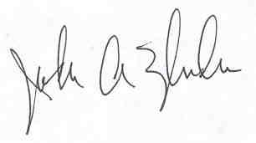
Joseph A. Zehnder
Professor
zehnder@asu.edu
480-965-5163

